**Anti-Lock Braking System and Simulation**

 It simulates the dynamic behaviour of a vehicle under hard braking conditions. The model represents a single wheel, which may be replicated a number of times to create a model for a multi-wheel vehicle.

In this model, the wheel speed is calculated in a separate model named sldemo\_wheelspeed\_absbrake. This component is then referenced using a 'Model' block. Note that both the top model and the referenced model use a variable step solver, so Simulink will track zero-crossings in the referenced model.

### Analysis and Physics

The wheel rotates with an initial angular speed that corresponds to the vehicle speed before the brakes are applied. We used separate integrators to compute wheel angular speed and vehicle speed. We use two speeds to calculate slip, which is determined by Equation 1. Note that we introduce vehicle speed expressed as an angular velocity (see below).

$$\omega_v = \frac{V}{R} \mbox{ (equals the wheel angular speed if there is no slip)}$$

**Equation 1**

$$ \omega_v = \frac{V_v}{R_r}$$

$$slip=1-\frac{\omega_w}{\omega_v}$$

$$\omega_v = \mbox{ vehicle speed divided by wheel radius}$$

$$ V_v = \mbox{ vehicle linear velocity}$$

$$ R_r = \mbox{ wheel radius}$$

$$ \omega_w = \mbox{ wheel angular velocity}$$

From these expressions, we see that slip is zero when wheel speed and vehicle speed are equal, and slip equals one when the wheel is locked. A desirable slip value is 0.2, which means that the number of wheel revolutions equals 0.8 times the number of revolutions under non-braking conditions with the same vehicle velocity. This maximizes the adhesion between the tire and road and minimizes the stopping distance with the available friction.

### Modeling

The friction coefficient between the tire and the road surface, mu, is an empirical function of slip, known as the mu-slip curve. We created mu-slip curves by passing MATLAB variables into the block diagram using a Simulink lookup table. The model multiplies the friction coefficient, mu, by the weight on the wheel, W, to yield the frictional force, Ff, acting on the circumference of the tire. Ff is divided by the vehicle mass to produce the vehicle deceleration, which the model integrates to obtain vehicle velocity.

In this model, we used an ideal anti-lock braking controller, that uses 'bang-bang' control based upon the error between actual slip and desired slip. We set the desired slip to the value of slip at which the mu-slip curve reaches a peak value, this being the optimum value for minimum braking distance.

To control the rate of change of brake pressure, the model subtracts actual slip from the desired slip and feeds this signal into a bang-bang control (+1 or -1, depending on the sign of the error). This on/off rate passes through a first-order lag that represents the delay associated with the hydraulic lines of the brake system. The model then integrates the filtered rate to yield the actual brake pressure. The resulting signal, multiplied by the piston area and radius with respect to the wheel (Kf), is the brake torque applied to the wheel.

The model multiplies the frictional force on the wheel by the wheel radius (Rr) to give the accelerating torque of the road surface on the wheel. The brake torque is subtracted to give the net torque on the wheel. Dividing the net torque by the wheel rotational inertia, I, yields the wheel acceleration, which is then integrated to provide wheel velocity. In order to keep the wheel speed and vehicle speed positive, limited integrators are used in this model.

Running vehicle simulation in ABS mode

The first plot shows the wheel angular velocity and corresponding vehicle angular velocity. This plot shows that the wheel speed stays below vehicle speed without locking up, with vehicle speed going to zero in less than 15 seconds.

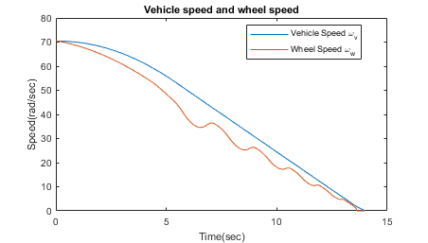

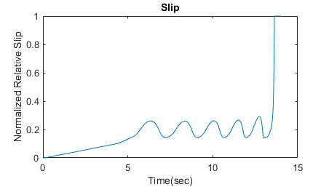

### Running the Simulation without ABS

Now let’s consider the behaviour without ABS. At the MATLAB command line, set the model variable ctrl = 0. This disconnects the slip feedback from the controller, resulting in maximum braking.

ctrl = 0;

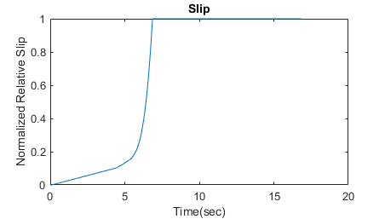

### Braking With ABS Versus Braking Without ABS

In the plot showing vehicle speed and wheel speed, observe that the wheel locks up in about seven seconds. The braking, from that point on, is applied in a less-than-optimal part of the slip curve. That is, when slip = 1, as the slip plot shows, the tire is skidding so much on the pavement that the friction force has dropped off.

This is, perhaps, more meaningful in terms of the comparison shown below. The distance traveled by the vehicle is plotted for the two cases. Without ABS, the vehicle skids about an extra 100 feet, taking about three seconds longer to come to a stop.

